Penetration Testing Report
Hazza Institute
Vulnerability Assessment Report
Prepared By: Mudassar Ali Zaman
Date: 26th August 2025
Confidentiality Level: Strictly Confidential
Version: Draft
Status: fail
1. Executive Summary
The OWASP Juice Shop application was tested as part of a controlled penetration test exercise. Automated scanning tools (Nmap, Nessus, Nikto, Acunetix) and manual verification were used to assess vulnerabilities according to the OWASP Web Security Testing Guide.
The test revealed multiple vulnerabilities across configuration, cryptography, client-side controls, denial of service, and information leakage. Critical findings include:
- Slow HTTP DoS attack (availability threat)
- *CORS misconfiguration (Access-Control-Allow-Origin: )
- Missing Content Security Policy (CSP) & Subresource Integrity (SRI)
- HSTS header missing → possible downgrade attacks
- robots.txt reveals sensitive path (/ftp)
These vulnerabilities map to several OWASP Top 10 categories and demonstrate that the target application is intentionally insecure.
2. Scope of Assessment
- Target: https://juice-shop.herokuapp.com/#/
- Testing Type: Black-box Web Application Vulnerability Assessment
- Tools: Nmap, Nessus, Nikto, Acunetix
- Standards Referenced: OWASP WSTG v4.2, OWASP Top 10 (2021)
3. Methodology (OWASP WSTG)
The testing process followed the 13 categories of the OWASP Web Security Testing Guide:
- Information Gathering
- Configuration and Deployment Management
- Identity Management
- Input Validation
- Error Handling
- Cryptography
- Business Logic
- Client-Side Testing
- Denial of Service
4. Findings
4.1 Information Gathering (WSTG-INFO)
- Web server fingerprinted as Heroku Router.
- robots.txt exposed /ftp directory (potential sensitive path).
- Uncommon headers (x-recruiting, reporting-endpoints) leaked system info.
Risk: Low (information disclosure).
Recommendation: Restrict information disclosure, remove sensitive paths from robots.txt.

4.2 Configuration & Deployment Management (WSTG-CONF)
- Missing CSP & SRI headers.
- Missing HSTS.
- CORS misconfiguration: Access-Control-Allow-Origin: *.
- Open HTTP (80) allowed alongside HTTPS (downgrade attack risk).
Risk: High.
Recommendation: Enforce HTTPS, configure secure headers, restrict CORS.
4.3 Input Validation (WSTG-INPV)
- Missing CSP & CORS → XSS risk.
Risk: High.
Recommendation: Validate and sanitize all inputs, enable CSP.

4.4 Error Handling (WSTG-ERRH)
- SSL certificate and TLS info disclosed (Nessus).
Risk: Low.
Recommendation: Restrict verbose error messages, harden TLS.

4.5 Cryptography (WSTG-CRYP)
- Weak SSL/TLS configurations identified by Nessus.
Risk: Medium.
Recommendation: Disable weak ciphers, enforce TLS 1.2/1.3.

4.6 Client-Side Testing (WSTG-CLNT)
- Missing CSP & SRI.
- Browser-side vulnerable to XSS / malicious script injection.
Risk: High.
Recommendation: Implement strict CSP & integrity checks.

4.7 Denial of Service (WSTG-DOS)
- Slow HTTP DoS attack confirmed (Acunetix).
Risk: High.
Recommendation: Implement request timeouts, rate limiting, and DoS protection.
Severity | Description | Count | Example Findings
Critical | Immediate exploitation, severe impact | 0 | –
High | High probability & high business impact | 4 | Slow HTTP DoS, Missing CSP/SRI, CORS misconfiguration, Open HTTP
Medium | Moderate probability, limited impact | 3 | Missing HSTS, Weak SSL/TLS configurations, robots.txt exposure
Low | Minor issues, informational, low risk | 2 | Information leakage via headers, TLS certificate details
6. Remediation Recommendations
Short-Term Actions (within 7 days)
- Fix Slow HTTP DoS vulnerability.
- Add/Enforce Content Security Policy (CSP) and Subresource Integrity (SRI).
- Correct CORS misconfiguration.
- Disable/Redirect Open HTTP access.
Medium-Term Actions (within 30 days)
- Enable and enforce HTTP Strict Transport Security (HSTS).
- Strengthen SSL/TLS configurations (remove weak ciphers/protocols).
- Restrict unnecessary exposure in robots.txt.
Long-Term Actions (within 90 days)
- Minimize information leakage via response headers.
- Replace/renew TLS certificates with stronger policies.
- Implement regular header/certificate audits.
7. Appendix
7.1 Tool Results
- Nmap: Open ports 80/443, robots.txt exposed /ftp.
- Nikto: Missing headers (CSP, HSTS), CORS misconfig.
- Nessus: Weak SSL/TLS, certificate info disclosure.
- Acunetix: Slow HTTP DoS, CSP/SRI missing.

7.2 Screenshots
NMAP
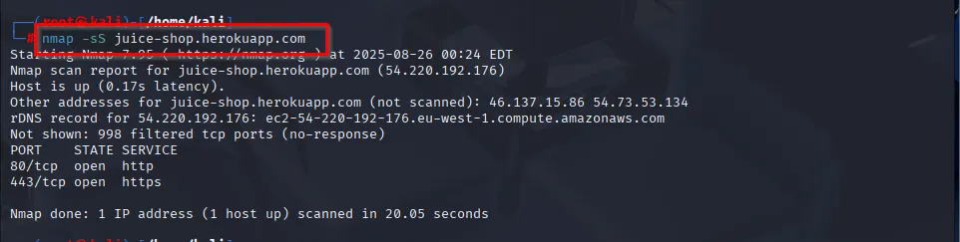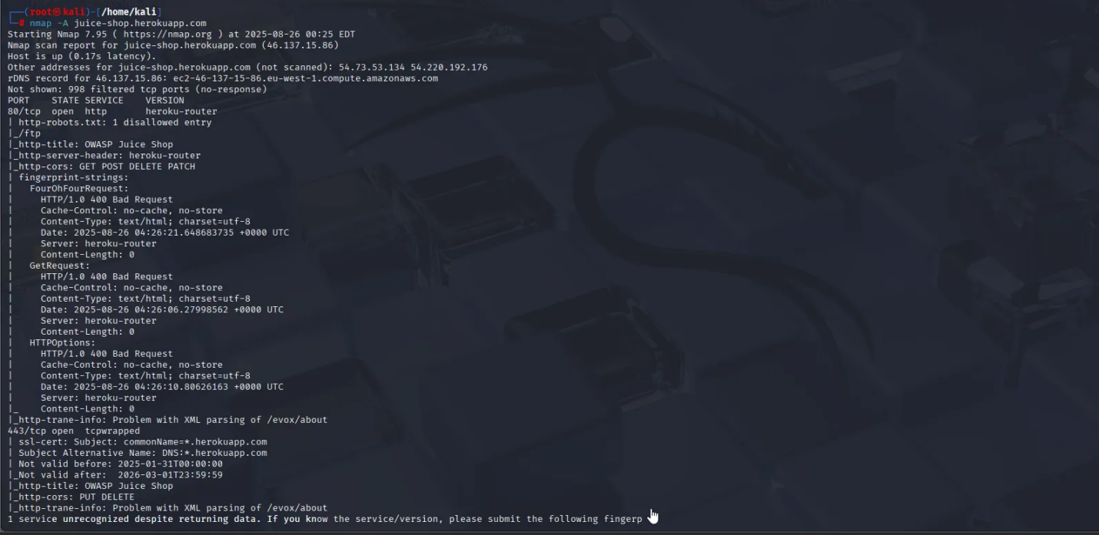

Nikto
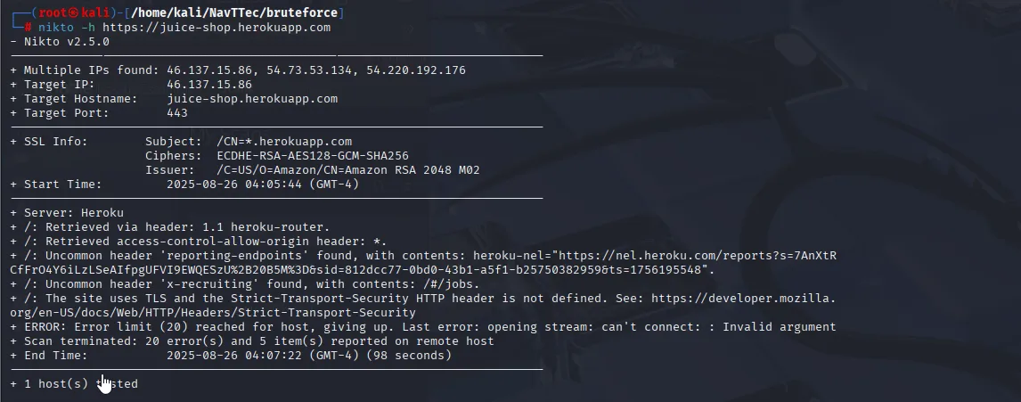
Nessus
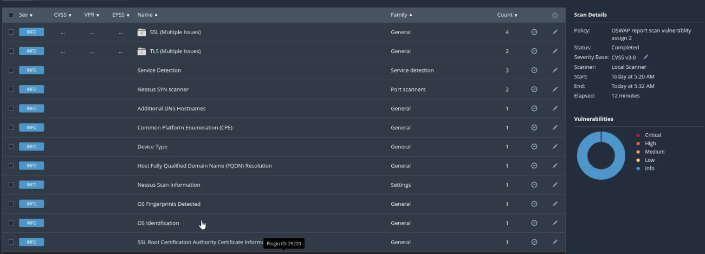
Acunetix 